Rest Assured

Methods

HTTP methods (GET, PUT, POST, PATCH and DELETE) and these methods can be mapped to CRUD operations.

**GET**retrieves the resource at a specified URI.

**PUT** updates a resource at a specified URI. Also be used to create a new resource at a specified URI. Replaces the entire product entity.

**PATCH** support partial updates.

**POST** creates a new resource.

**DELETE** deletes a resource at a specified URI.

* Create a maven project
* Create a new package then

File 🡪 new 🡪 project 🡪 maven project 🡪 select simple project

Then finish.

* GET 1

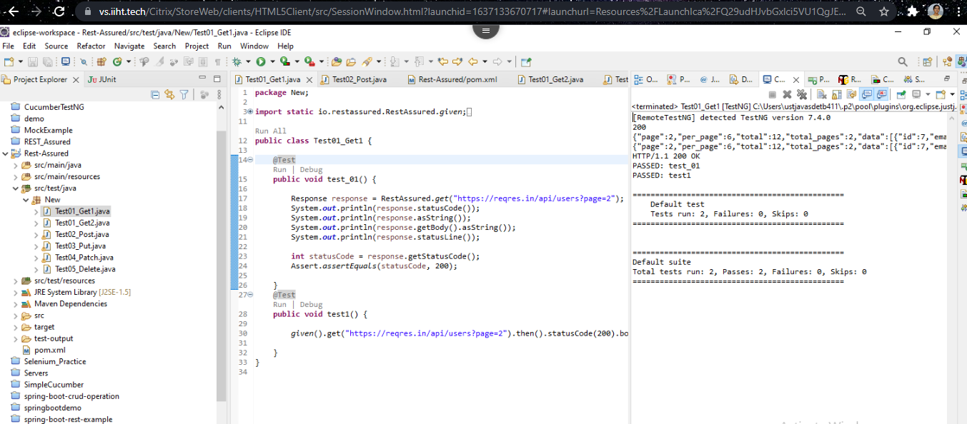

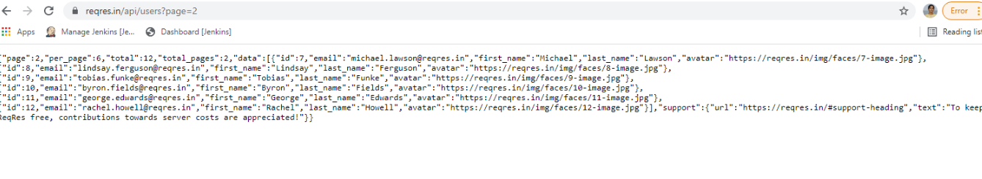

* GET 2

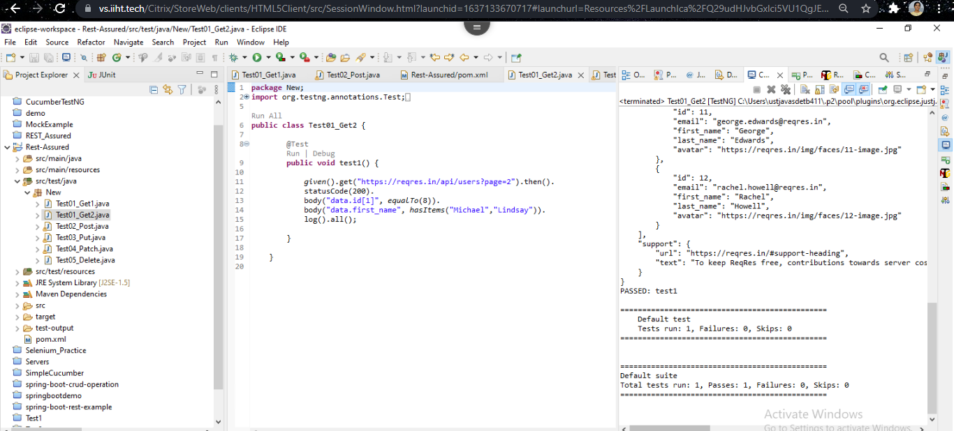



* POST

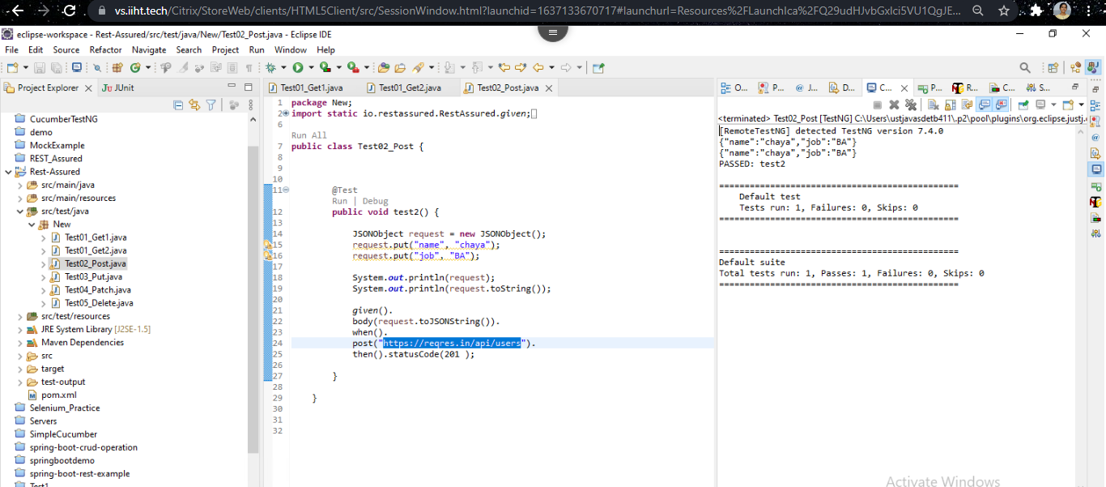

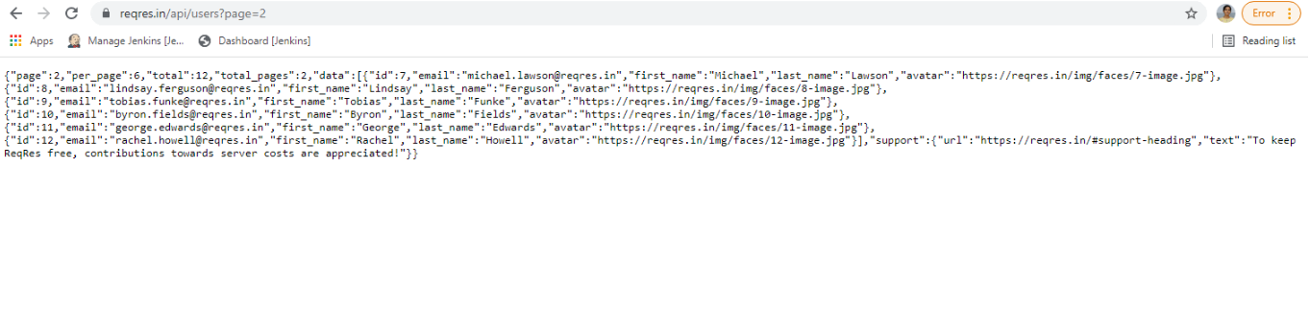

* PUT

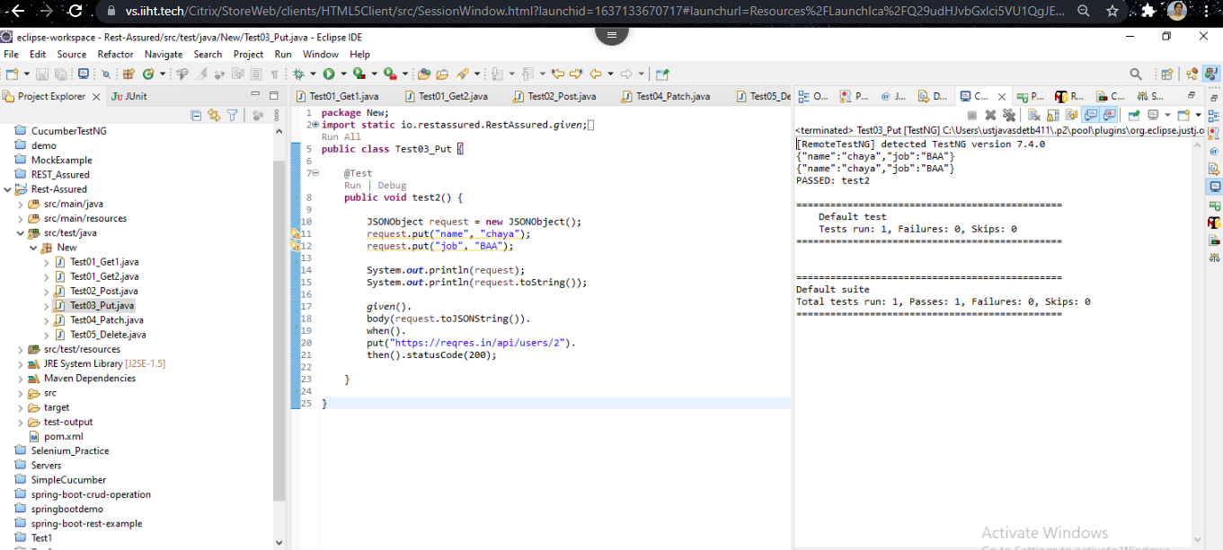

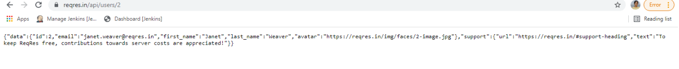

* PATCH

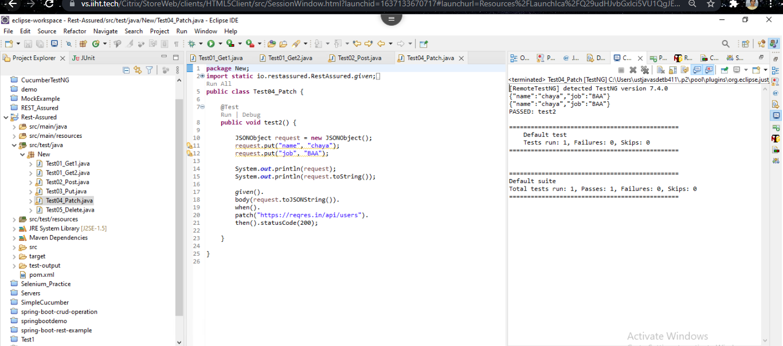

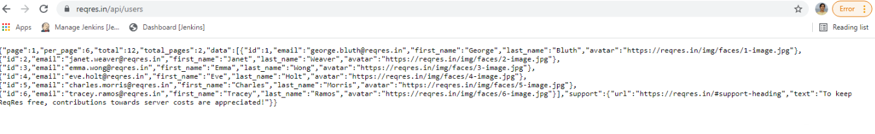

* DELETE

